Hydrogels help stem cells reverse blindness, heal brains By Stephen Feller | May 14, 2015 at 2:58 PM

The eyes and brains of mice began to function properly after being injected with a gel containing stem cells, showing promise for other stem cell therapies.

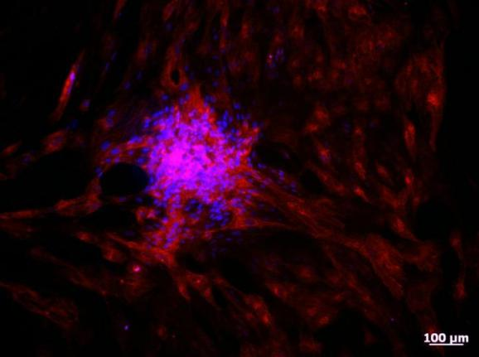
In the study, stem cell-derived photoreceptor cells were injected into the retina (pictured), leading to improved eyesight. Photo: University of Toronto
TORONTO, May 14 (UPI) -- Scientists have successfully implanted organs grown from stem cells, however direct injection of stem cells for treatment has mostly failed because the cells often die after being introduced into the body.
Stem cells injected into mice using a hydrogel survived introduction into the rodents' bodies, restoring eyesight and repairing brain injuries after stroke, showing promise that high hopes for stem cell therapy have not been misplaced, a new study found.
The hydrogel, invented at the University of Toronto by professor Molly Shoichet, is made up of hyaluronan, which keeps stem cells alive, and methylcellulose, a chemical compound that forms a solution which holds the stem cells together.
Originally, the substance was used to hold stem cells together when being injected into a transplant site to help healing and acceptance new organs by the body.
"This study goes one step further, showing that the hydrogels do more than just hold stem cells together; they directly promote stem cell survival and integration," Shoichet said in apress release. "This brings stem-cell based therapy closer to reality."
Photoreceptors, grown from stem cells, were injected into the eyes of blind mice using the hydrogel. These cells, what eyes use to detect light, began to restore about 15 percent function to the pupils. Researchers also saw mice that had recently suffered strokes start to regain motor function after stem cells were injected into their brains.
Since the cell injections were successful in two different parts of the nervous system, researchers think the hydrogel would be effective in other parts of the body as well.

